Case study: REAL TIME TWITTER SENTIMENT ANALYSIS USING KAFKA

Exercise:

Working with Live data is what we do in the Industries. Famous franchises like Amazon, Netflix, Twitter and many more are dependent on analyzing live data. In this case study, we are going to integrate Twitter with Kafka and Kafka with Spark Streaming for Live data collection and analyzing them in Spark Streaming.

Let’s do the exercise in six easy steps.
Step 1: Generate keys in Twitter application

Step 2: Scala IDE Installation

Step 3: Add required libraries for Twitter-Spark integration and add Java code

Step 4: Get twitter live by starting Kafka broker and adding arguments

Step 5: Add required libraries for Kafka-spark integration and add Scala code

Step 6: Let’s witness the Twitter- Kafka-and-Spark Streaming Integration.

Prerequisites: You need to have a twitter account to get the keys. Understand Maven or SBT or generating Jars from them to add them in your project. Run Kafka and zookeeper servers.

STEP – 1:
GENERATING KEYS
IN
TWITTER APPLICATION

OAuth tokens:
OAuth tokens are nothing but the keys which we receive from Twitter apps. Using these tokens the third party services gets access to the host or resource server. Here we use these keys while running our project code. OAuth is distinct from OATH; it’s reference architecture for authentication, not standard for authorization.

Let’s create your oAuth tokens for Scala project.

How to get API Keys and Tokens for Twitter:

In order to get the Twitter feed working with your Scala console we need four keys

- The Consumer Key
- Consumer Secret key
- Access Token and
- Access Token Secret.

Below are the steps to get those 4 keys:

- Go to https://apps.twitter.com/app/new and log in, if necessary.

- Enter your desired Application Name, Description and your website address making sure to enter the full address including the ‘http://’. You can leave the call back URL empty.

Note: You can specify ‘any application name’ and ‘description’ of your wish. The same way enter ‘any website address’ you desire.

- Accept the TOS and submit the form by clicking the Create your Twitter Application.

- After creating your Twitter Application click on the tab that says Keys and Access Tokens, and now click the Create my Access Token button, and you can find the required keys.

- Lastly copy the Consumer key (API key), Consumer Secret, Access Token and Access Token Secret from the screen and paste it in your note pad for the future use.

Step 2: Scala IDE Installation

How to setup a Spark development environment on eclipse:

You have two methods to do this.

Add a plugin in your existing Java based eclipse

Download your Scala IDE from http://scala-ide.org/ .

*If you don’t have an eclipse installed, I suggest you to follow the second step. It gives you both Java and Scala console. We create both java and Scala projects here.

Option 1: Go to Eclipse -> Help- > Eclipse Marketplace:

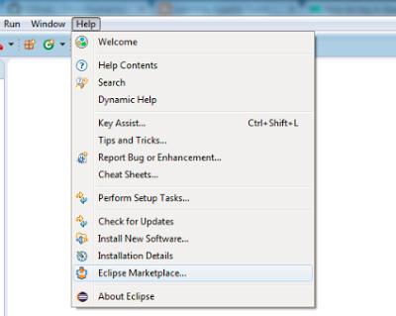

Under search Tab type in "Scala". Select Scala IDE x.x.x and click on "Install"

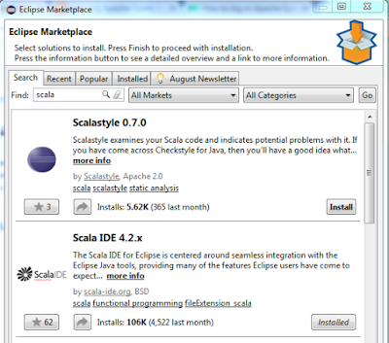

Option 2: Download Scala IDE directly from http://scala-ide.org/

NOTE: Check your Scala Version:

Right click on the project. Go to Properties > Scala Compiler > Click on the checkbox "Use Project Settings"
Under Scala Installation dropdown select "Fixed Scala Installation: 2.10.6 (built in)"

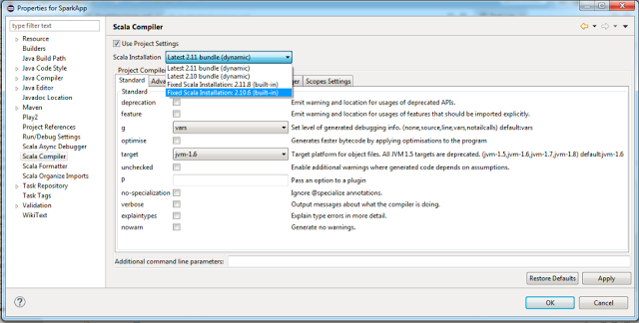

Step 3: Add required libraries for Twitter-Spark integration and add Java code

MAVEN DEPENDENCIES:

Method-1

Create a Maven Project:

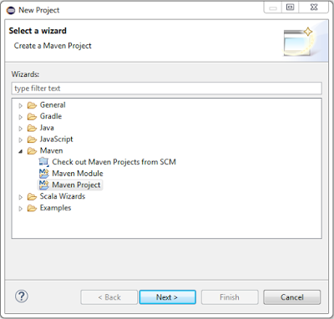

Enter the Group ID and Artifact ID or it gives you by default and click on Finish.

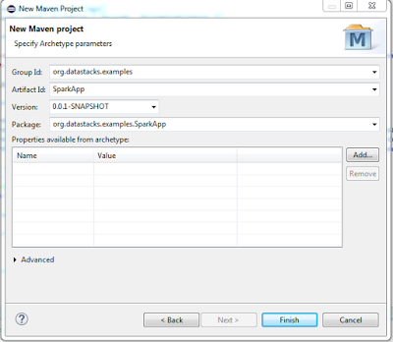

Now you get a POM.XML file where you add the below code after <build> tag. They are dependencies which add the Jars for your project.

Update the pom.xml with the list of dependencies:

<dependencies>
<dependency>
<groupId>org.apache.spark</groupId>
<artifactId>spark-core_2.10</artifactId>
<version>1.4.1</version>
<scope>compile</scope>
</dependency>
<dependency>
<groupId>org.apache.spark</groupId>
<artifactId>spark-streaming_2.10</artifactId>
<version>1.4.1</version>
<scope>compile</scope>
</dependency>
<dependency>
<groupId>org.apache.spark</groupId>
<artifactId>spark-mllib_2.10</artifactId>
<version>1.4.1</version>
</dependency>
<dependency>
<groupId>org.apache.spark</groupId>
<artifactId>spark-sql_2.10</artifactId>
<version>1.4.1</version>
</dependency>
<dependency>
<groupId>org.apache.spark</groupId>
<artifactId>spark-hive_2.10</artifactId>
<version>1.4.1</version>
</dependency>
<dependency>
<groupId>org.apache.spark</groupId>
<artifactId>spark-streaming-twitter_2.10</artifactId>
<version>1.4.1</version>
</dependency>
<dependency>
<groupId>org.apache.spark</groupId>
<artifactId>spark-streaming-kafka_2.10</artifactId>
<version>1.4.1</version>
</dependency>
<dependency>
<groupId>org.apache.hadoop</groupId>
<artifactId>hadoop-client</artifactId>
<version>2.4.1</version>
<scope>compile</scope>
</dependency>
<dependency>
<groupId>org.apache.hadoop</groupId>
<artifactId>hadoop-common</artifactId>
<version>2.4.1</version>
<scope>compile</scope>
</dependency>
<dependency>
<groupId>org.apache.spark</groupId>
<artifactId>spark-streaming-flume_2.10</artifactId>
<version>1.4.1</version>
</dependency>
</dependencies>

ADD YOUR DEPENDENCIES AS FOLLOWS:

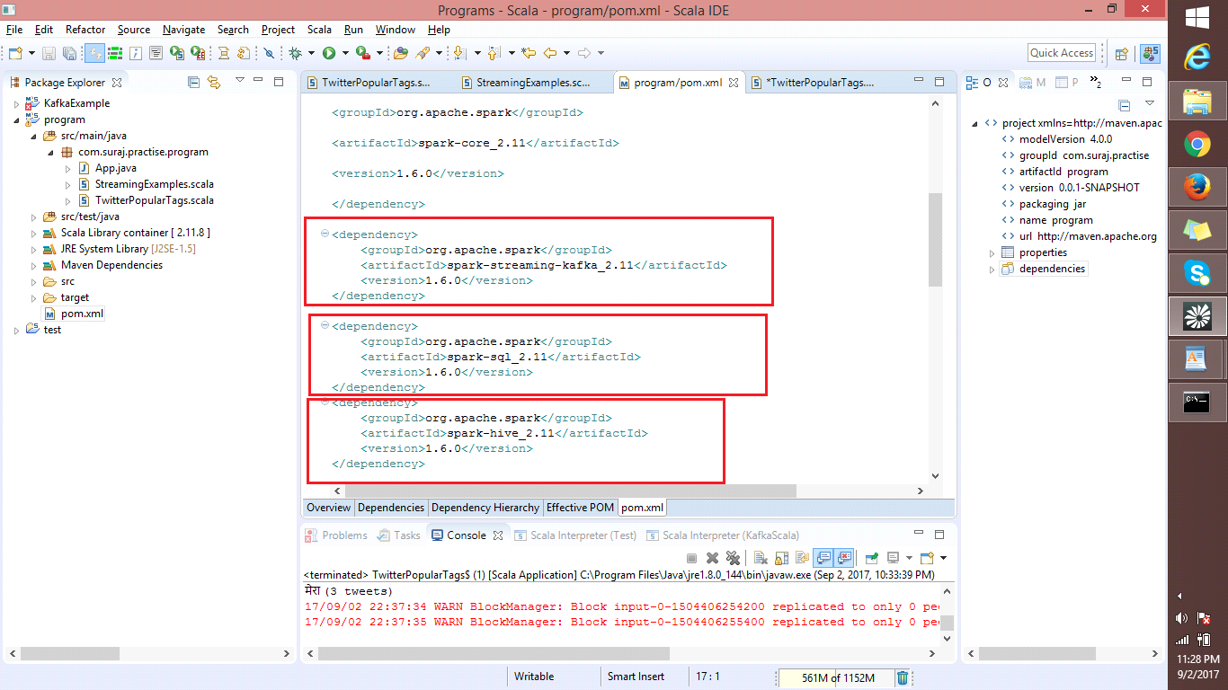

Add JAVA Class:
Right click on the project you just created. New java Class.
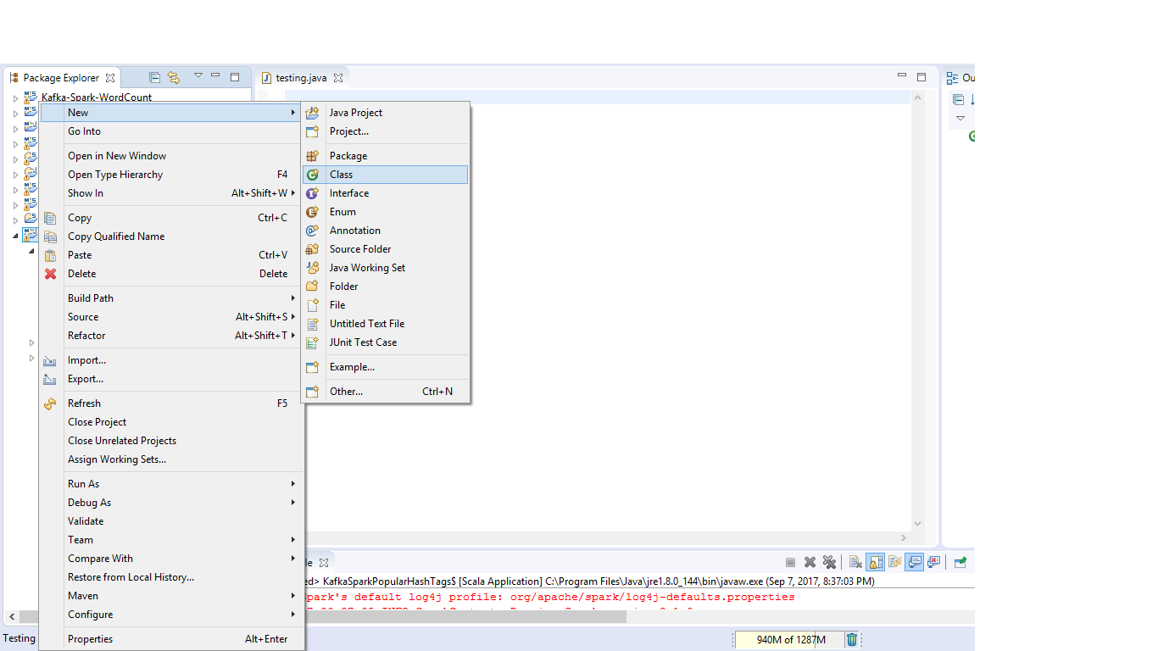

NOTE: On your project name ‘M’ indicates Maven nature ‘J’ indicates Java nature, ‘S’ indicates Scala nature.
SUBMIT YOUR CODE:
import java.util.Arrays;
import java.util.Properties;
import java.util.concurrent.LinkedBlockingQueue;

import twitter4j.*;
import twitter4j.conf.*;

import twitter4j.StallWarning;
import twitter4j.Status;
import twitter4j.StatusDeletionNotice;
import twitter4j.StatusListener;
import twitter4j.TwitterStream;
import twitter4j.TwitterStreamFactory;
import twitter4j.conf.ConfigurationBuilder;
import twitter4j.json.DataObjectFactory;

import org.apache.kafka.clients.producer.Producer;
import org.apache.kafka.clients.producer.KafkaProducer;
import org.apache.kafka.clients.producer.ProducerRecord;
import kafka.producer.KeyedMessage;
/**
* A Kafka Producer that gets tweets on certain keywords
* from twitter datasource and publishes to a kafka topic
*
* Arguments: <comsumerKey> <consumerSecret> <accessToken>
<accessTokenSecret> <topic-name> <keyword_1> ... <keyword_n>
* <comsumerKey> - Twitter consumer key
* <consumerSecret> - Twitter consumer secret
* <accessToken> - Twitter access token
* <accessTokenSecret> - Twitter access token secret
* <topic-name> - The kafka topic to subscribe to
* <keyword_1> - The keyword to filter tweets
* <keyword_n> - Any number of keywords to filter tweets
* /
public class KafkaTwitterProducer {
public static void main(String[] args) throws Exception {
final LinkedBlockingQueue<Status> queue = newLinkedBlockingQueue<Status>(1000);
if (args.length < 4) {
System.out.println(
"Usage: KafkaTwitterProducer <twitter-consumer-key> <twitter-consumer-secret>
<twitter-access-token> <twitter-access-token-secret> <topic-name> <twitter-search-keywords>");
return;
}
String consumerKey = args[0].toString();
String consumerSecret = args[1].toString();
String accessToken = args[2].toString();
String accessTokenSecret = args[3].toString();
String topicName = args[4].toString();
String[] arguments = args.clone();
String[] keyWords = Arrays.copyOfRange(arguments, 5, arguments.length);
// Set twitter oAuth tokens in the configuration
ConfigurationBuilder cb = new ConfigurationBuilder();
cb.setDebugEnabled(true).setOAuthConsumerKey(consumerKey).setOAuthConsumerSecret(consumerSecret)
.setOAuthAccessToken(accessToken).setOAuthAccessTokenSecret(accessTokenSecret);
// Create twitterstream using the configuration
TwitterStream twitterStream = new TwitterStreamFactory(cb.build()).getInstance();
StatusListener listener = new StatusListener() {
@Override
public void onStatus(Status status) {
queue.offer(status);
}

@Override
public void onDeletionNotice(StatusDeletionNotice statusDeletionNotice) {
System.out.println("Got a status deletion notice id:" + statusDeletionNotice.getStatusId());
}

@Override
public void onTrackLimitationNotice(int numberOfLimitedStatuses) {
System.out.println("Got track limitation notice:" + numberOfLimitedStatuses);
}

@Override
public void onScrubGeo(long userId, long upToStatusId) {
System.out.println("Got scrub_geo event userId:" + userId + "upToStatusId:" + upToStatusId);
}

@Override
public void onStallWarning(StallWarning warning) {
System.out.println("Got stall warning:" + warning);
}

@Override
public void onException(Exception ex) {
ex.printStackTrace();
}
};
twitterStream.addListener(listener);
// Filter keywords
FilterQuery query = new FilterQuery().track(keyWords);
twitterStream.filter(query);
// Add Kafka producer config settings
Properties props = new Properties();
props.put("metadata.broker.list", "localhost:9092");
props.put("bootstrap.servers", "localhost:9092");
props.put("acks", "all");
props.put("retries", 0);
props.put("batch.size", 16384);
props.put("linger.ms", 1);
props.put("buffer.memory", 33554432);

props.put("key.serializer","org.apache.kafka.common.serialization.StringSerializer");
props.put("value.serializer","org.apache.kafka.common.serialization.StringSerializer");
Producer<String, String> producer = new KafkaProducer<String, String>(props);
int i = 0;
int j = 0;

// poll for new tweets in the queue. If new tweets are added, send them
//to the topic
while (true) {
Status ret = queue.poll();

if (ret == null) {
Thread.sleep(100);
// i++;
} else {
for (HashtagEntity hashtage : ret.getHashtagEntities()) {
System.out.println("Tweet:" + ret);
System.out.println("Hashtag: " + hashtage.getText());
// producer.send(new ProducerRecord<String, String>(
// topicName, Integer.toString(j++), hashtage.getText()));
producer.send(new ProducerRecord<String, String>(topicName,Integer.toString(j++), ret.getText()));
}
}
}
}
}

NOTE: If you find errors in your code, that indicates you haven’t added the required dependencies properly. Make sure you do it right.

Some other methods
METHOD -2:
- Create a Java class and add your code initially, you can witness a huge no of errors.
- Right click -> Convert to maven Project -> Add dependencies in POM.XML
- Check you don’t have any errors.
METHOD – 3 [Another Way of adding Jars to your Project]:
- Have your Maven dependencies with you and go to https://jar-download.com/
- Maven-online-tool -> Paste your Dependency [Not all] -> Submit -> Your jars get Downloaded. Do it for all your required ones.
- In you Project Right click -> Build Path-> Configure Build path -> Add external Jars -> Add your downloaded jars.
Method- 4 – Add the jars using SBT Simple built tool.

Step 4: Get twitter live by starting Kafka broker and adding arguments

Now your source code is ready to act, start your Kafka Broker now to collect the Live Twitter data.

- Starting Zookeeper
bin/zookeeper-server-start.sh config/zookeeper.properties:
- Starting Kafka
bin/kafka-server-start.sh config/server.properties
- Create a topic and name it ‘tweets’:
bin/kafka-topics.sh --create --zookeeper localhost:2181 --replication- factor 1 --partitions 1 --topic tweets

- Check if topic has been created:
/usr/local/kafka/bin/kafka-topics.sh --list --zookeeper localhost:2181

- Run the Kafka Producer:
Kafka-console-producer.bat --broker-list localhost:9092 --topic tweets

- Run the Kafka Consumer:
kafka-console-consumer.bat --zookeeper localhost:2181 --topic test

Now let’s run our source code.

Right click on your Twitter-kafka Integrating project name ->
Select Run as -> Run configurations ->
‘Select your project and class name properly’ ->
Select arguments tab ->
Add your Twitter keys here
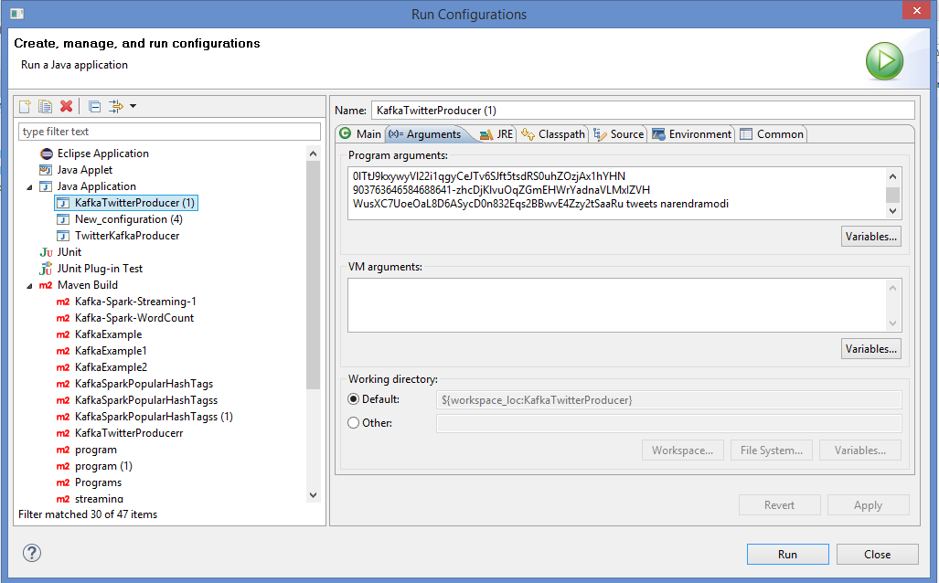

- You can add the Keys in the same order as you have copied.
- Make sure your producer and consumer are active with the same topic name, and add your topic name along with the keys as shown above.
- Beside your topic name give your Hash tag name as mentioned.

In the kafka producer java project, right click on Kafka Twitter Producer.
java > Run configurations > Arguments

Add the 4 twitter oAuth tokens followed by the kafka topic to consume and keywords seperated by space.

IF everything goes well you will find your Twitter live data coming in your console. You can even check your Kafka producer which receives these logs.
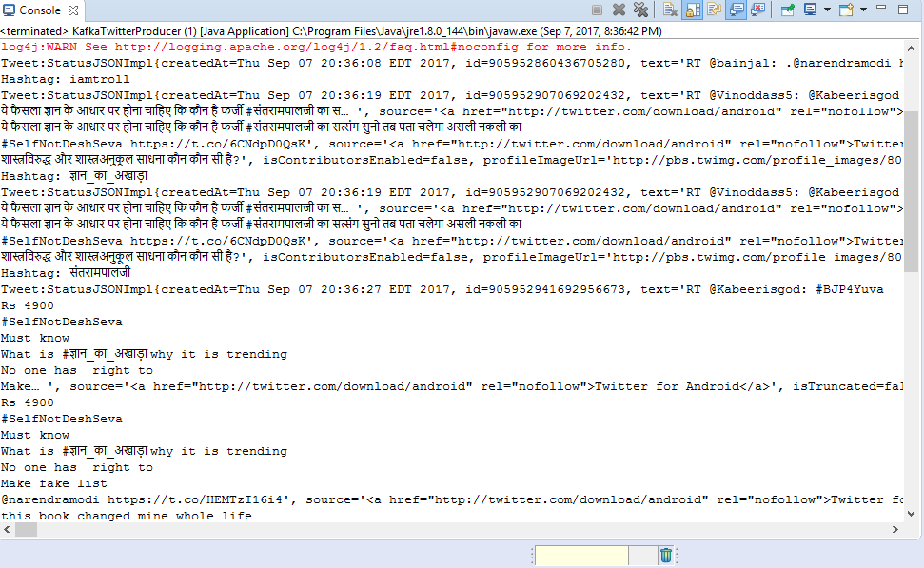

Step 5: Add required libraries for Kafka-spark integration and add Scala code

Now create a new Scala project for integrating this Kafka data with our Spark-Streaming.

Create a Scala Object:

Right click on the Package within the Project. Select Scala Object. Type in a name and click "Finish"

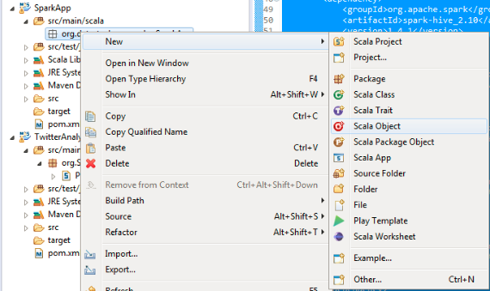
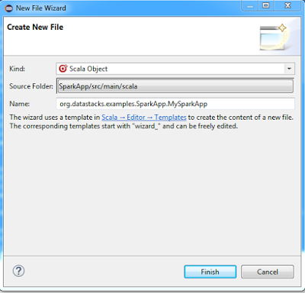

Convert into Maven project to add its required dependencies.

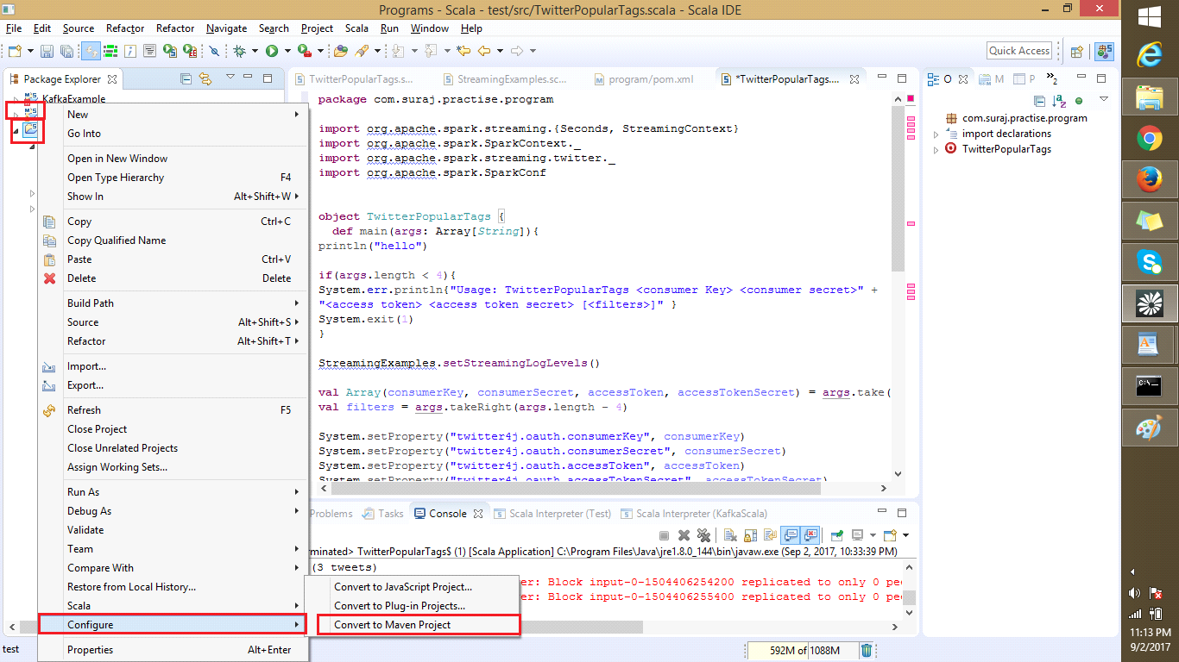

Notice the POM.XML file
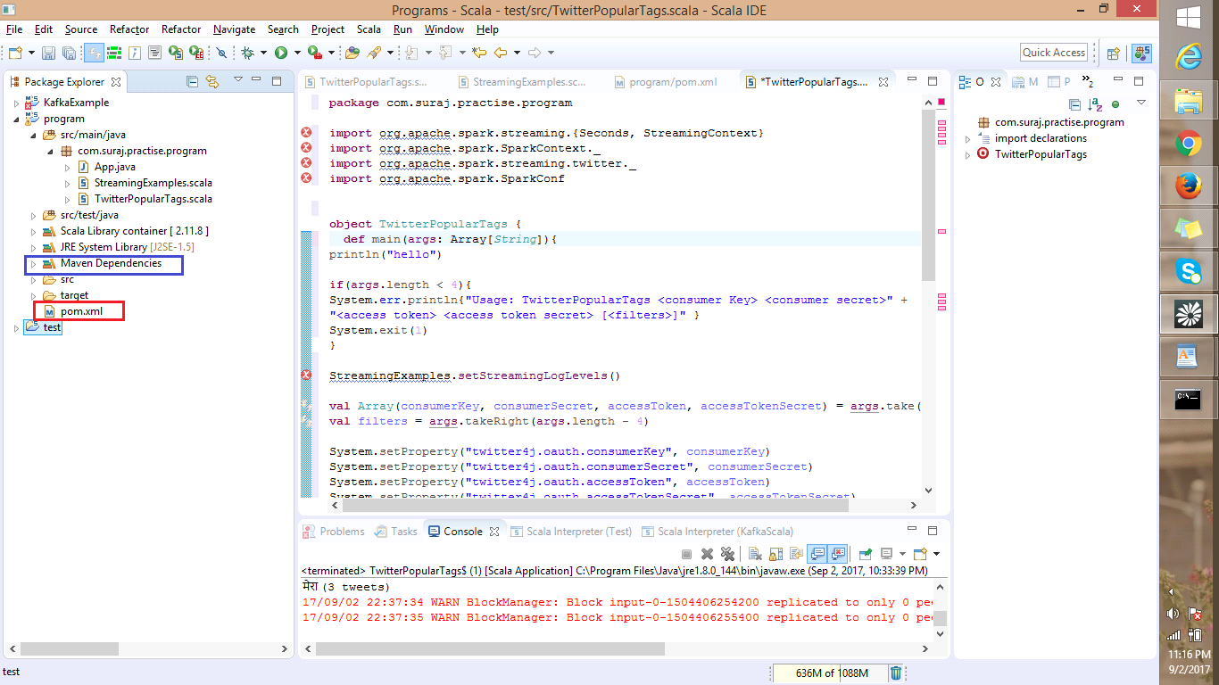

Now add your dependencies in POM.XML which are same as given above

Now After you add you Dependencies Select Maven Install and Maven Repositories. Now you can see the Maven Dependencies Tab with all your required jars as shown below.

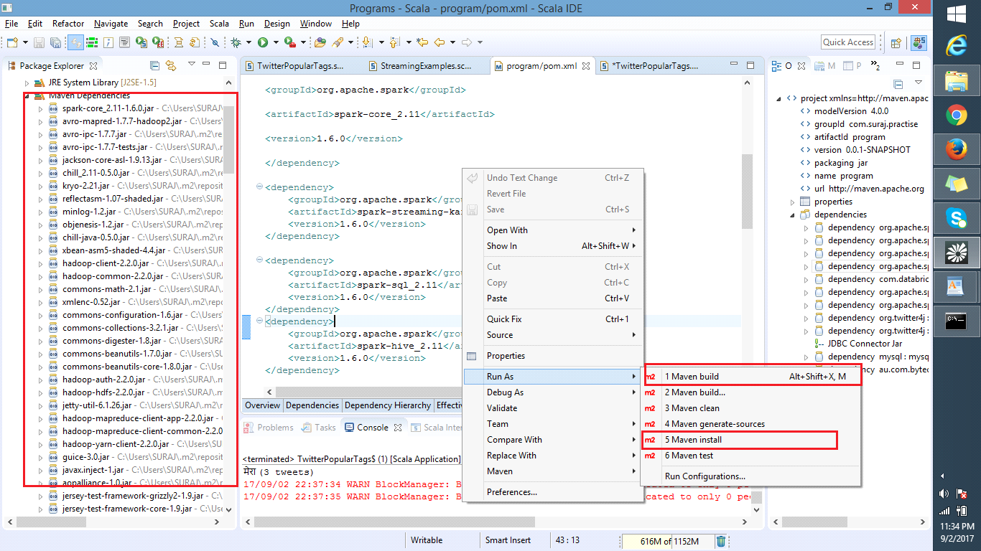

Add the Scala Source code:

import java.util.HashMap

import org.apache.kafka.clients.producer.{ KafkaProducer, ProducerConfig, ProducerRecord }
import org.apache.spark.SparkConf
import org.apache.spark.streaming._
import org.apache.spark.streaming.kafka._
import org.apache.spark.streaming.{ Seconds, StreamingContext }
import org.apache.spark.SparkContext._
import org.apache.spark.streaming.twitter._
import org.apache.spark.SparkConf
import org.apache.spark.streaming._
import org.apache.spark.{ SparkContext, SparkConf }
import org.apache.spark.storage.StorageLevel

/**
* A Spark Streaming - Kafka integration to receive twitter
* data from kafka topic and find the popular hashtags
*
* Arguments: <zkQuorum> <consumer-group> <topics> <numThreads>
* <zkQuorum> - The zookeeper hostname
* <consumer-group> - The Kafka consumer group
* <topics> - The kafka topic to subscribe to
* <numThreads> - Number of kafka receivers to run in parallel

*/

object KafkaSparkPopularHashTags {

val conf = new SparkConf().setMaster("local[6]").setAppName("Spark Streaming - Kafka Producer - PopularHashTags").set("spark.executor.memory", "1g")
val sc = new SparkContext(conf)

def main(args: Array[String]) {

sc.setLogLevel("WARN")

// Create an array of arguments: zookeeper hostname/ip,consumer group, topicname, num of threads
val Array(zkQuorum, group, topics, numThreads) = args

// Set the Spark StreamingContext to create a DStream for every 2 seconds
val ssc = new StreamingContext(sc, Seconds(2))
ssc.checkpoint("checkpoint")

// Map each topic to a thread
val topicMap = topics.split(",").map((_, numThreads.toInt)).toMap
// Map value from the kafka message (k, v) pair
val lines = KafkaUtils.createStream(ssc, zkQuorum, group, topicMap).map(_._2)
// Filter hashtags
val hashTags = lines.flatMap(_.split(" ")).filter(_.startsWith("#"))

// Get the top hashtags over the previous 60/10 sec window
val topCounts60 = hashTags.map((_, 1)).reduceByKeyAndWindow(_ + _, Seconds(60))
.map { case (topic, count) => (count, topic) }
.transform(_.sortByKey(false))

val topCounts10 = hashTags.map((_, 1)).reduceByKeyAndWindow(_ + _, Seconds(10))
.map { case (topic, count) => (count, topic) }
.transform(_.sortByKey(false))

lines.print()

// Print popular hashtags
topCounts60.foreachRDD(rdd => {
val topList = rdd.take(10)
println("\nPopular topics in last 60 seconds (%s total):".format(rdd.count()))
topList.foreach { case (count, tag) => println("%s (%s tweets)".format(tag, count)) }
})

topCounts10.foreachRDD(rdd => {
val topList = rdd.take(10)
println("\nPopular topics in last 10 seconds (%s total):".format(rdd.count()))
topList.foreach { case (count, tag) => println("%s (%s tweets)".format(tag, count)) }
})

lines.count().map(cnt => "Received " + cnt + " kafka messages.").print()

ssc.start()
ssc.awaitTermination()
}
}

We count the popular hash tags with the below code:

val topCounts60 = hashTags.map((_, 1)).reduceByKeyAndWindow(_ + _, Seconds(60))
.map{case (topic, count) => (count, topic)}
.transform(_.sortByKey(false))

This code counts your top twitter hash tags over the previous 60 seconds and provides them for every 10 secs as specified. The reduceByKeyAndWindow is a transformation and sorts them in descending order.

Step 6: Let’s witness the Twitter- Kafka-and-Spark Streaming Integration.

We have performed the same action as we have done for earlier integration. Make sure that you don’t have any errors before running this source code.

Now Right click on your source code -> Run as -> Run configurations -> Select arguments ->

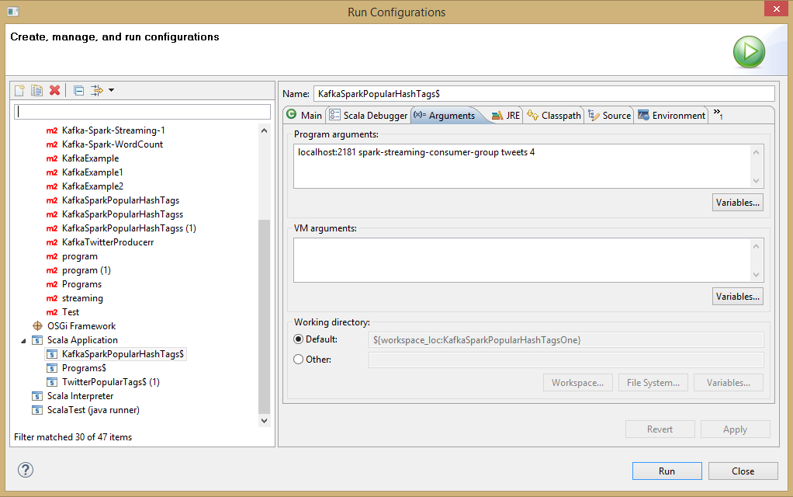

Open "New Console View" in eclipse as we can see both program outputs at the same time.

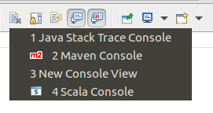

Now as per the code we will receive the Top 7 Hash tags for every 60 seconds. For every 10 seconds we receive this info, this time duration is known as Window time in Spark-Streaming.

If everything is perfect without errors we see the output as follows.
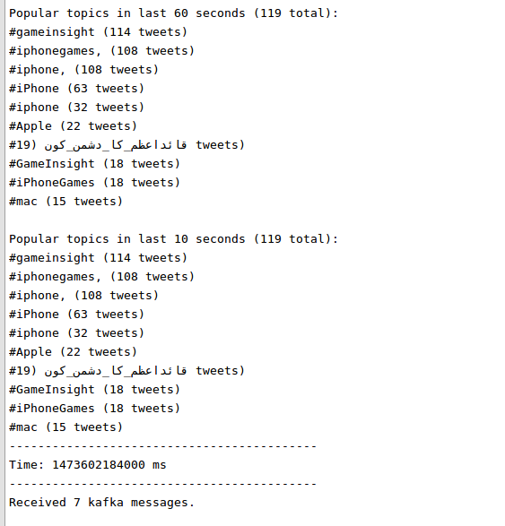

Successfully we have integrated Twitter with Kafka and Kafka with Spark-Streaming.

Note: If you receive an error make your Hadoop or Spark is in latest version. For older versions we need to add ‘winutils lib’ not for new versions. Make sure you have them right.

Relevant Information :

Kafka :

Kafka is a pub-sub based messaging system that is distributed, partitioned, replicated and fault tolerant.

- It maintains feeds of messages in categories called topics.
- Kafka producers publish messages to topics.
- Kafka consumers subscribe to topics and process the published feed.
- Kafka broker is a cluster of one or more servers.

What does each of the producer configurations setting mean?
- metadata.broker.list - Where the producer can find one or more brokers to determine the leader of a topic
- bootstrap.servers - List of host:port to establish initial connection to kafka cluster
- acks - Number of acknowledgements the leader should have received for the producer to consider the request as complete
- retries - Value greater than zero will cause the client to resend the record on failure
- batch.size - Total size of records to be batched together
- linger.ms - Small delay to be induced to allow the transmission of the sent records to be completed
- buffer.memory - Amount of memory available to the producer for buffering
- key.serializer - Serializer call for key
- value.serializer - Serializer call for value

